**Computational Neuroscience – Project 2**

**Group 3**

**Contributions:**

* Aditya Sinha – Parts 1 to 11 and report
* Vijay Bhaskar – Parts 12 to 20

**Part 1: Morris-Lecar Equations (MLE)**

1. While choosing sets of units, we must be consistent. In the given example:

Now, we take the current and conductance both per unit area. In that case, if *G~mS/cm2* and *V~mV*, then *I~μA/cm2.*

Also,

Now*, V~mV, t~ms*, *C~ μF/cm2*. Therefore, *I~ μF/cm2*(mV/ms)→ I~ μA/cm2*

Hence, the given system of units is **consistent**.

If we were to express conductance as *μS/cm2*, we would need to change the units of either V up 3 orders (Volts) or I down 3 orders (nA/cm2) to keep the system consistent. However, this solution is not unique, since consistent units are defined relative to each other.

1. The first set of MLE parameters were set as described and the equilibrium was found at Iext=0. The two methods used to find the equilibrium point were:

* See the intersection of the null clines, using analytic solution.
* See the trajectory and the destination of a signal when started from an initial condition.

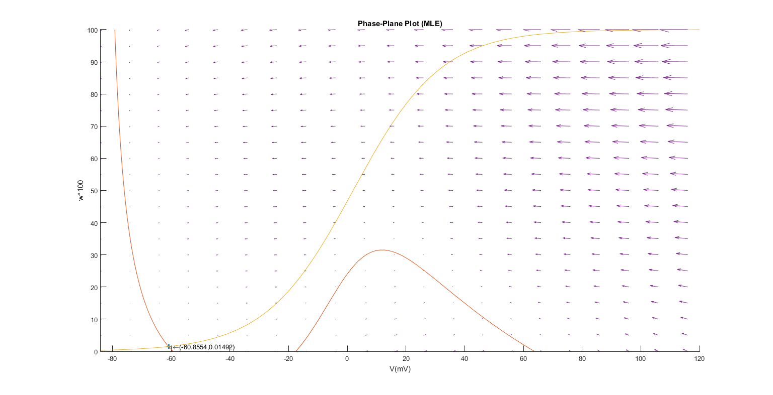

The above plot shows the V-null cline, w-null cline, equilibrium point and quiver plot of the vector field. For the latter, the w-axis has been scaled up a 100 times to get a good looking plot.

1. To check the stability of the equilibrium point, we perform linearization around it and find the eigenvalues of the Jacobian at the equilibrium point.

The eigenvalues found are:

Now, since both the eigenvalues are real and negative, the equilibrium point is ***“stable”***.

1. *AbsTol* and *RelTol* define the absolute and relative tolerances of the ODE solver used for solving the system of differential equations.

***AbsTol=min(X1-X2)***, ie. the least difference between observations. So, if AbsTol is 10-6, then we can differentiate two points at least 10-6 units apart.

***RelTol=(X1-X2)/min(abs(X1),abs(X2))***

Now, in the case of MLE, we have voltage in mV and time steps in ms. So, according to RelTol, our resolution is 0.001, while AbsTol says it is 10-6 mV. This level of resolution is reasonable for our simulation purposes.

Now, if voltage is set in kV, AbsTol currently says that the resolution is 10-6 kV = 1 mV, which is not enough. So, *AbsTol will have to be changed to 10-9*. The value of RelTol can be left as is, as it only measures relative resolution, wrt. current unit and is independent of the unit chosen.

1. Action potentials were generated for different values of Φ (0.01, 0.02 and 0.04), starting from the same initial condition.

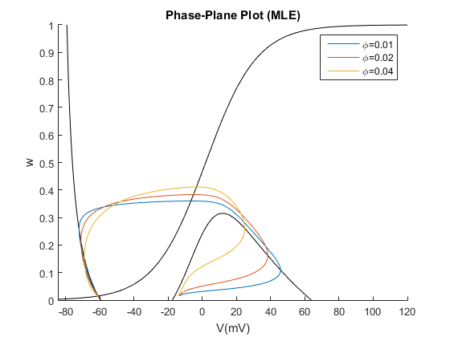

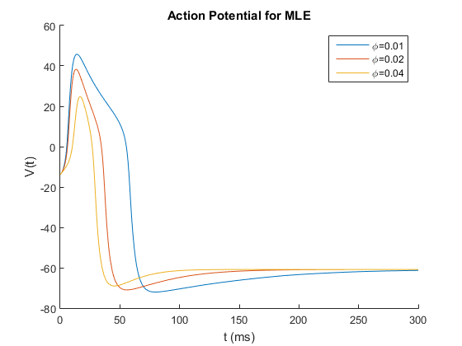

As Φ is increased, the time constant of w decreases and w varies faster. As a result, we observe a sharper action potential, but with lesser amplitude. In the phase plane, we see w varying quickly in order to hyperpolarize the cell earlier and reduce the magnitude and duration of the action potential.

1. To simulate depolarizing current pulses, an equivalent experiment is to displace the initial starting point from the equilibrium bya voltage equal to q/C. The value of w is kept at and the experiment is performed for various initial voltages.

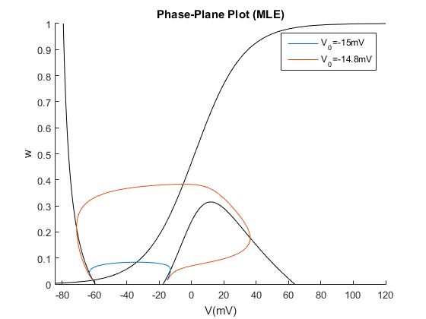

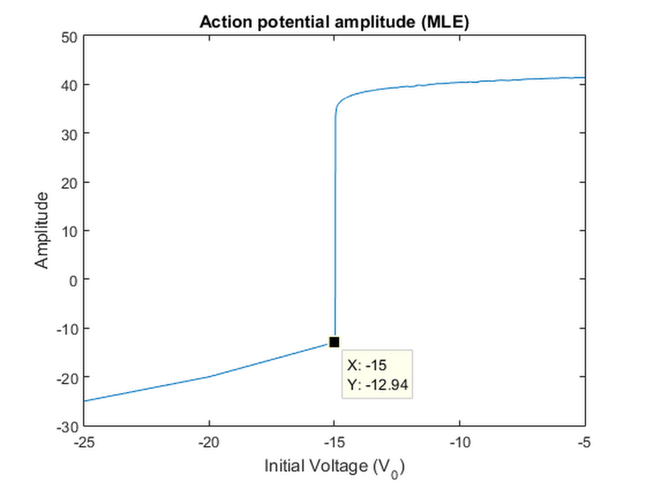

We can see that about V0 = -15mV, we have a sort of threshold, beyond which there is an action potential. However, since the maximum amplitude doesn’t increase all of a sudden at -15mV, but gradually increases, it is not a true threshold. For a true threshold, an infinitesimal change in V should bring about a sudden change in maximum amplitude. For MLE, a sudden change in phase plane behavior is not seen.

1. At Iext= 86 μA/cm2, the V-nullcline will shift up, resulting in displacement of the equilibrium point. Now, according to the three initial conditions, the model is simulated.

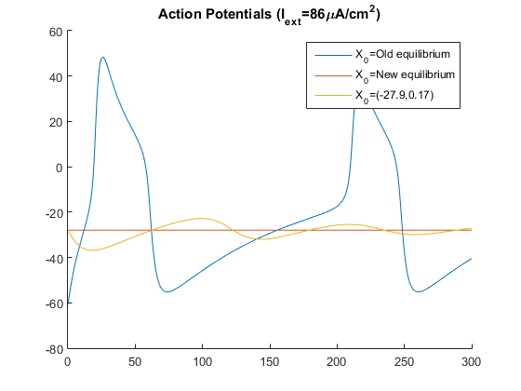

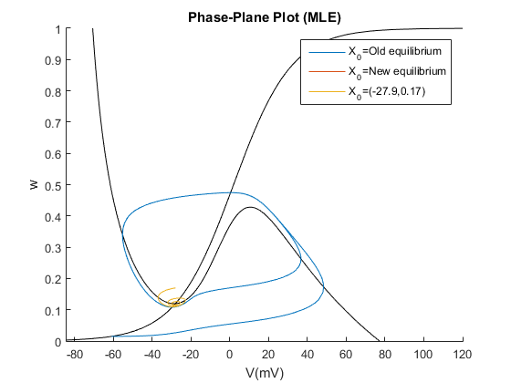

Since the new equilibrium is a stable spiral, starting the system at the new equilibrium point doesn’t yield much of a trajectory. Even the third condition yields a stable spiral. However, when started from the old equilibrium point, we observe the trajectory converging into a limit cycle. This may seem at odds with the Poincare-Benedixon theorem, but in reality, this system has two stable states – stable equilibrium point and limit cycle (Stable Periodic Orbit SPO). Their dominant regions are separated by an Unstable Periodic Orbit (UPO), which delineates the effect of the two.

Since the two eigenvalues are complex conjugates with negative real parts, the equilibrium point is a ***“stable spiral”***.

Now, to **conduct the first two trials**, we take the system withIext= 0 μA/cm2 and let it settle to the stable equilibrium. Now, 1) we give the cell a step current inputIext= 86*u(t-t0)μA/cm2. This will result in trajectory 1. Now, 2) a small well-timed current pulse can push the trajectory inside the UPO, resulting in it falling into the stable spiral, resulting in trajectory 3. After it settles at eqm, it can be again excited using a current pulse to bring it into repetitive firing in the limit cycle.

This is depicted in the following figure, taken from Rinzel and Ermentrout’s chapter on neural excitability. Note that, to turn off the repetitive firing, we need to properly time the current pulse such that the neuron is hyperpolarized and a current pulse pushes the trajectory inside the UPO.

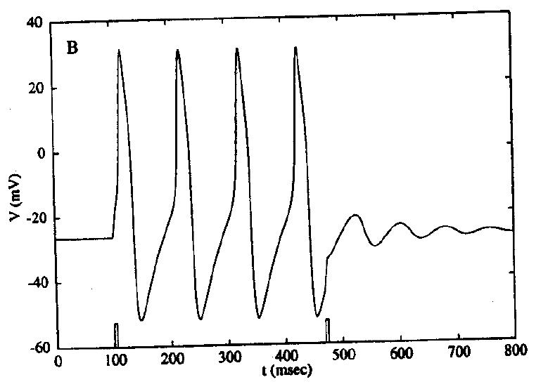

1. To obtain the contour that seperates the two stable state dominant influence regions is the Unstable Periodic Orbit (UPO). This is found in the manner of finding the stable manifold of the stable spiral equilibrium – by running the model backwards in time from equilibrium.

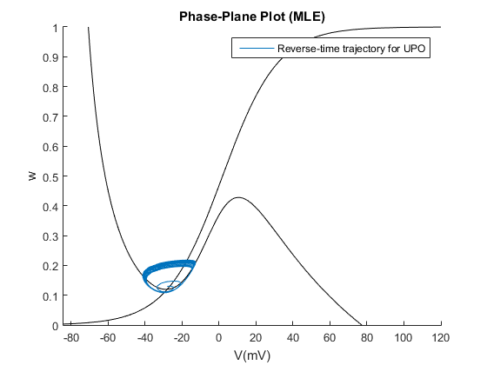

Now, we take the **convex hull** of this reverse-time trajectory to get the UPO.

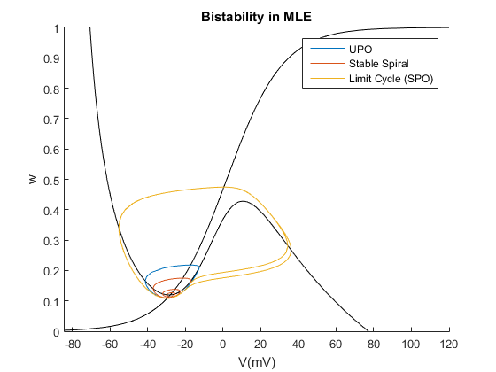

As we can see from this phase plot, the UPO acts as a true threshold, and a small displacement across the UPO results in completely different behavior. This is also an all or none event, since if the initial voltage crosses the threshold, we have only one amplitude, corresponding to the limit cycle (SPO).

This can also be observed if we look at the action potential amplitude variation with initial voltage. We note that there is a sharp transition and the maximum amplitude remains more or less constant post-threshold.

When we run the model backwards in time, the null clines remain the same, the stability of the equilibrium points reverse as the eigenvalues become negative of what they were before. This allows us to see the stable manifolds by temporarily considering the point as unstable.

This phenomenon of having two stable states with a UPO separating them is called **Bistability**.

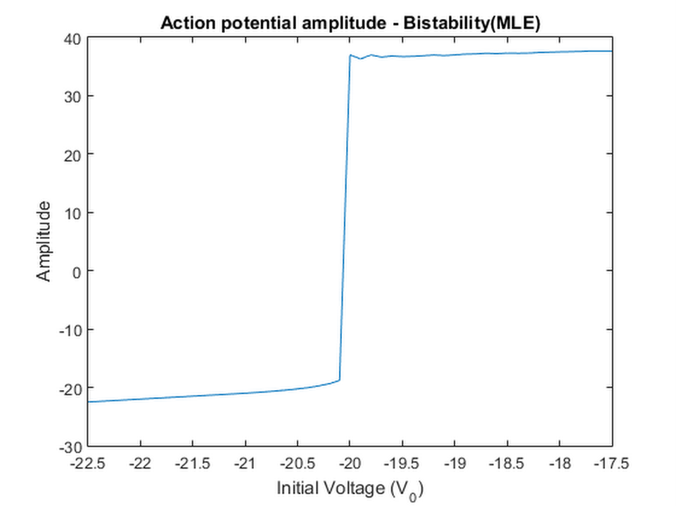

1. The equilibrium points for the three external current values are:

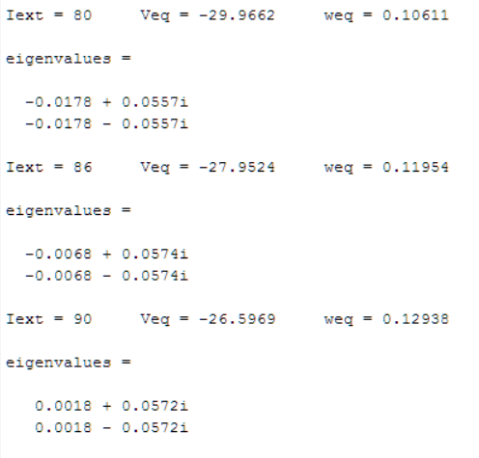

So, for Iext= 80μA/cm2 and 80μA/cm2, the equilibrium point is a stable spiral. However, due to **Hopf bifurcation** somewhere between 86 and 90, the stable spiral becomes an unstable spiral and we have the existence of a limit cycle. This leads to repetitive firing of action potential, whose rate we can measure.

This proposition by the eigenvalues of the system linearized around equilibrium is indeed correct, as observed when the trajectories are actually seen for the three cases.

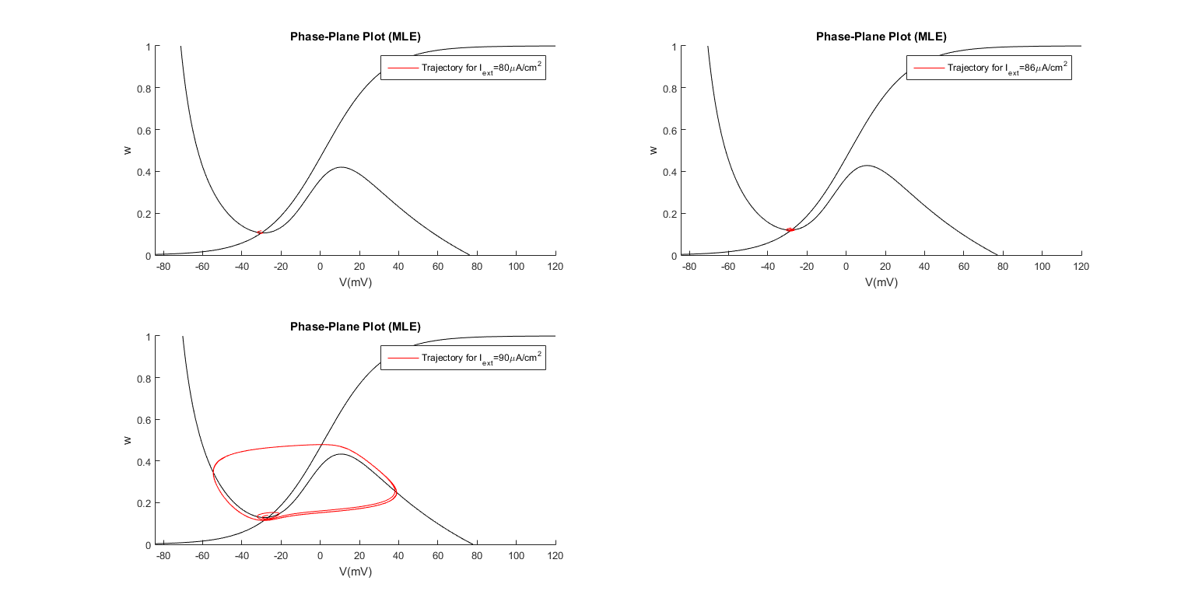

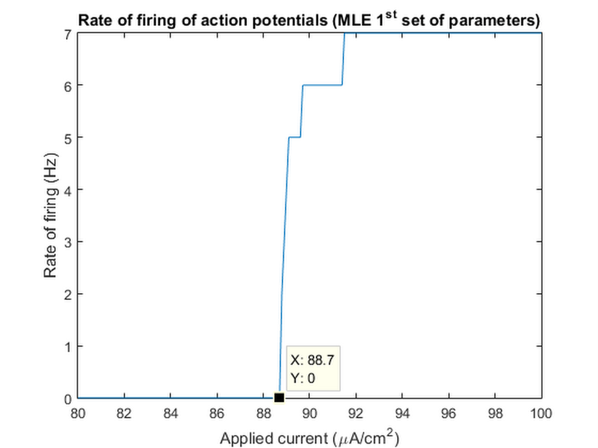

So, atIext= 80μA/cm2, we have Hopf bifurcation, resulting in a limit cycle and repetitive firing.

1. *(Second set of MLE parameters)*

For this second set of MLE parameters, with at Iext= 30μA/cm2, we have 3 intersections of the nullclines, resulting in 3 equilibrium points.

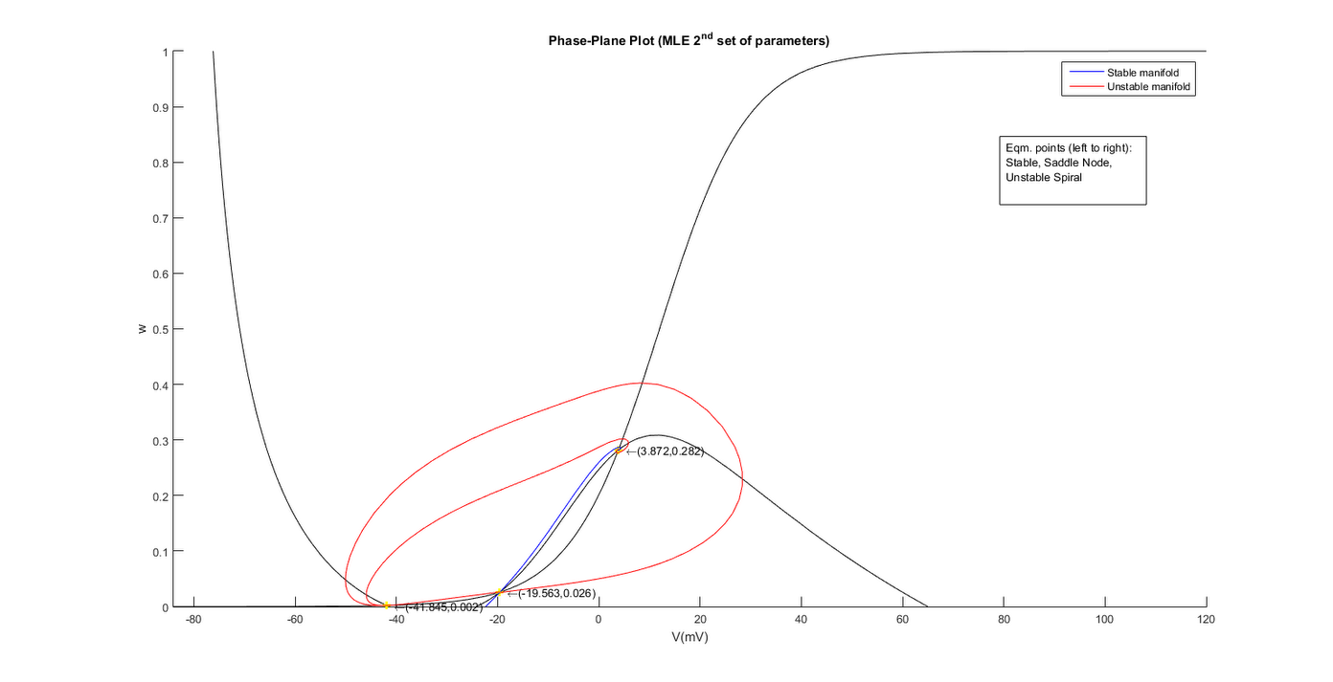

The three equilibrium points are ***stable, saddle node, unstable spiral***. This can be seen from the manifolds as well as from the eigenvalues:

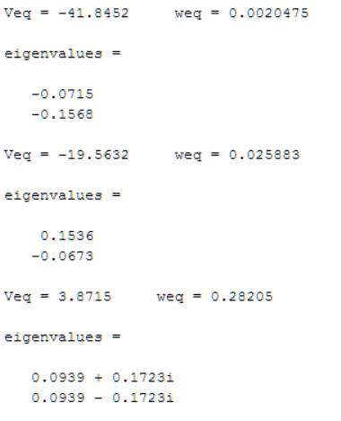

*(Both real and negative -* ***Stable****)*

*(Both real and opposite signs –* ***Saddle node****)*

*(Complex conjugates with positive real parts–****Unstable Spiral****)*

1. For the system defined above, we intend to see the bifurcation effect upon changing Iext, which is varied from 30to 50 μA/cm2.

Upon sweeping the current, we observe that after a certain value, the V-nullcline shifts up sufficiently so that there is only one equilibrium point (intersection) now ie. bifurcation takes place.

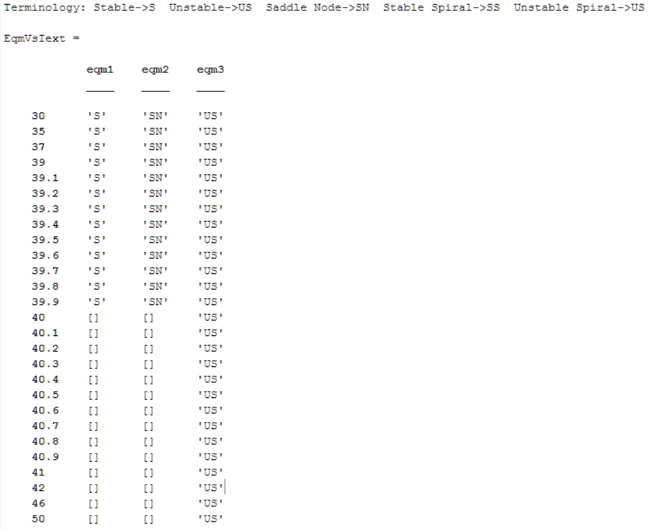

So, we can see that at **Iext= 39.9μA/cm2** we have an unstable spiral equilibrium, while the other two equilibriums are no longer there.

This change results in the creation of a limit cycle, leading to a non-zero rate of firing in the steady state beyond Iext= 39.9 μA/cm2. This rate keeps increasing as the current is increased and the equilibrium point becomes more and more unstable.

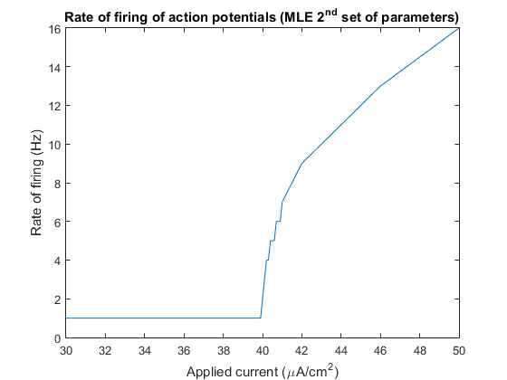

**Part 2: Hodgkin-Huxley Equations (HH)**

1. A separate function was written apart from main one consisting HH model so that it can be called any number of times.
2. To calculate EL necessary to make Vr = -60mV, meq, heq & neq were calculated.

1. The stability of the equilibrium point can be determined by the eigen values of the jacobian at that point.

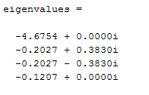

As all λi’s are complex such that Re(λi) <0, the equilibrium point is a stable spiral.

The below plot is used to determine action potential threshold. We can observe that action potential is fired as soon as membrane potential is greater than Vth = -53.493mV

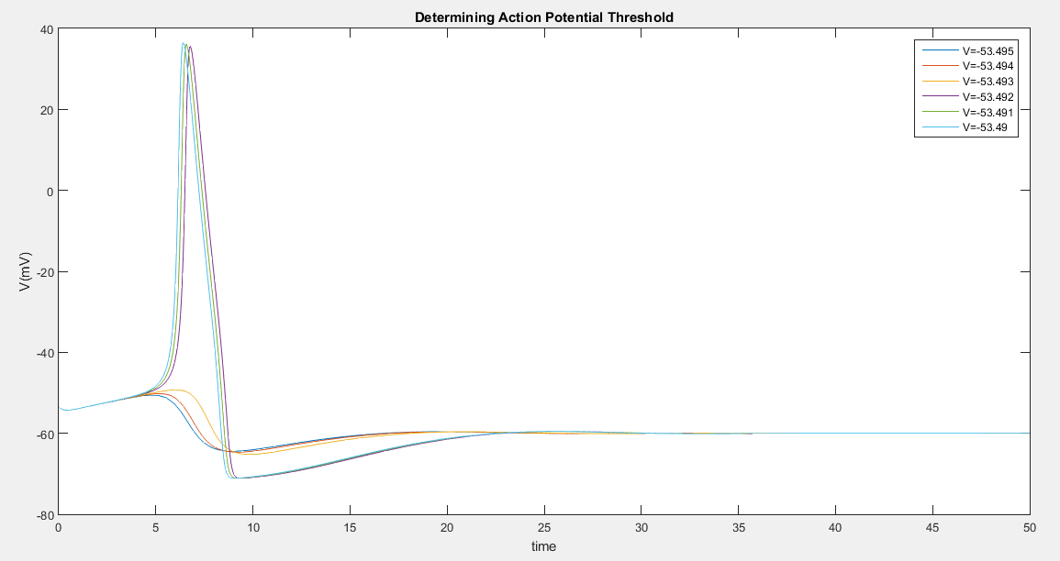

1. Steady state current injections ranging from 8µA/cm2 to 12µA/cm2 was given and respective equilibrium points were determined.

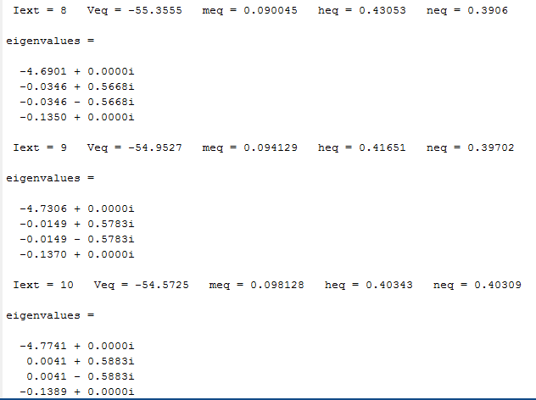

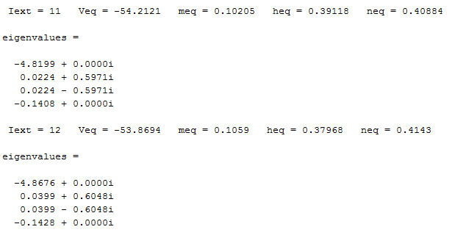

We can oberve that for Iext of 8 µA/cm2 & 9 µA/cm2 the equilibrium point is stable whereas for greater values, it is a saddle node.

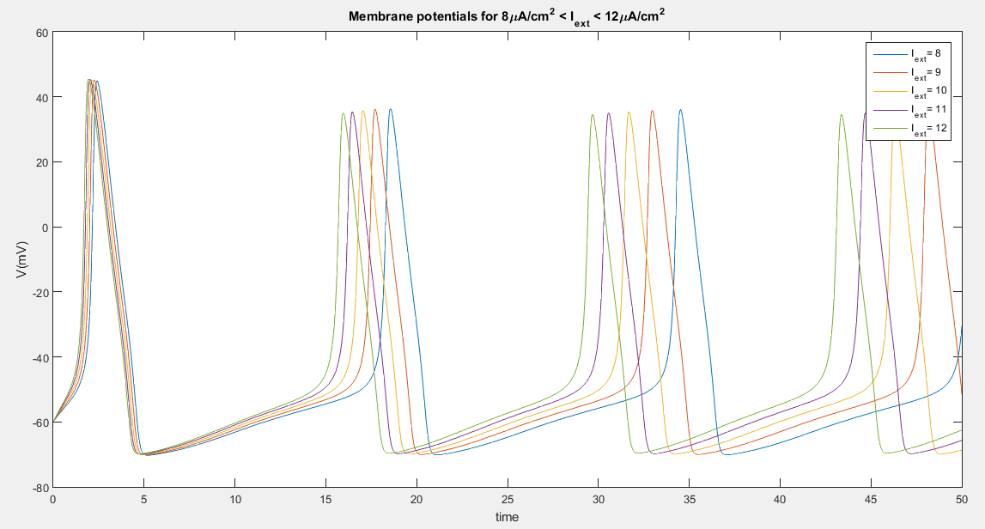

The above plot is of the membrane potentials with initial conditions of the equilibrium point for the case of Iext =0. Although equilibrium points for Iext of 8 µA/cm2 & 9 µA/cm2 are stable, we can still observe action potentials being fired as the phase plot trajectoried converge onto the limit cycle instead of the respective equilibrium points. This is due to the same bistability effect that we have earlier observed in parts 7 and 8 (MLE).

Also, Veq plotted against Iext gives the following.

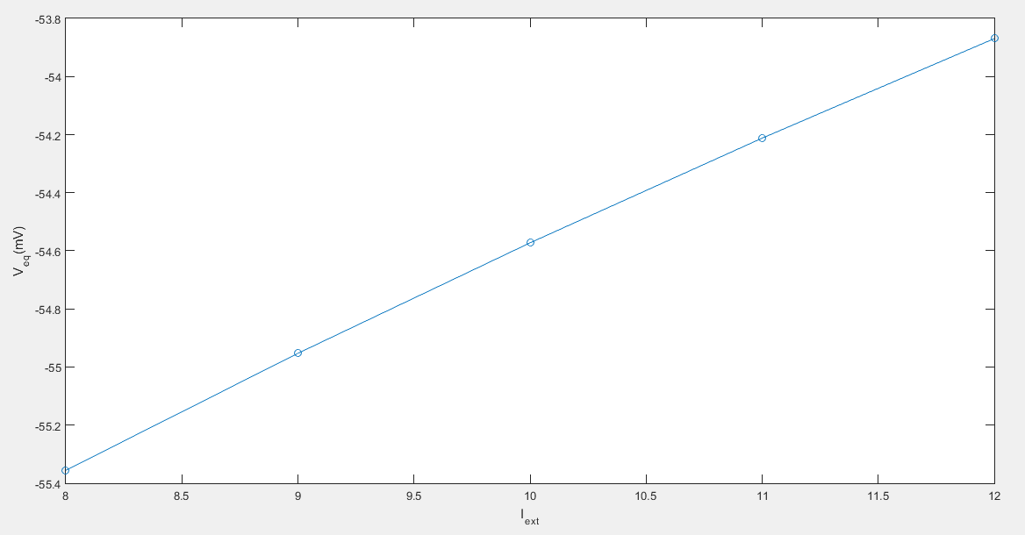

1. The case of myotonia requires a slight modification in HH system regarding Na+ ion channel current and is hence, written in a separate function which can be called.

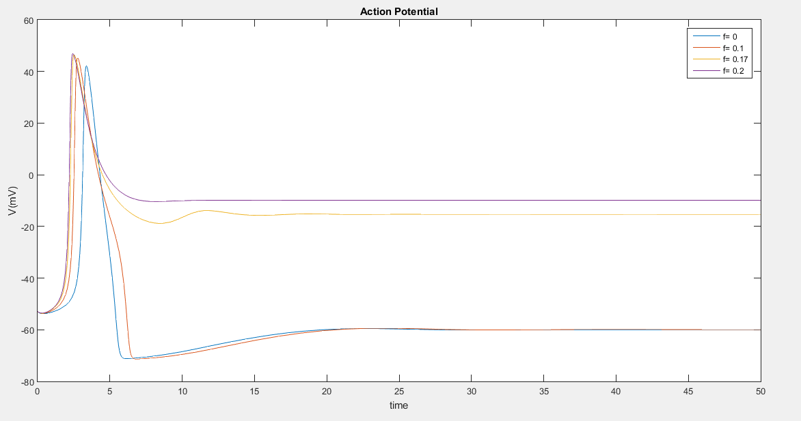

The above plot can be used to observe that both the action potential shape as well as the steady-state membrane potential post action potential change very much with the value of ‘**f**’.

The reason for this is that as more and more h gates go into non-inactivation, the cell loses it’s ability to hyperpolarize. In terms of the n-V phase plane plot in the reduced model, there is a Hopf bifurcation, where Unstable Spiral becomes Stable Spiral as f increases. Therefore, it becomes an attractor and prevents hyperpolarization (2 stable states now). This is evident for ***f=0.17 and f=0.2***.

1. The n-V reduced model of HH system is written as a separate function which can be called in the main function.

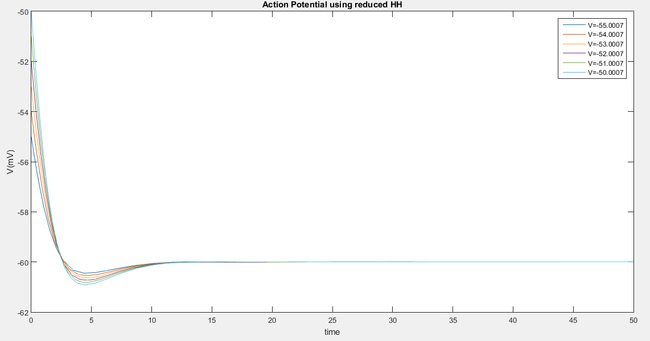

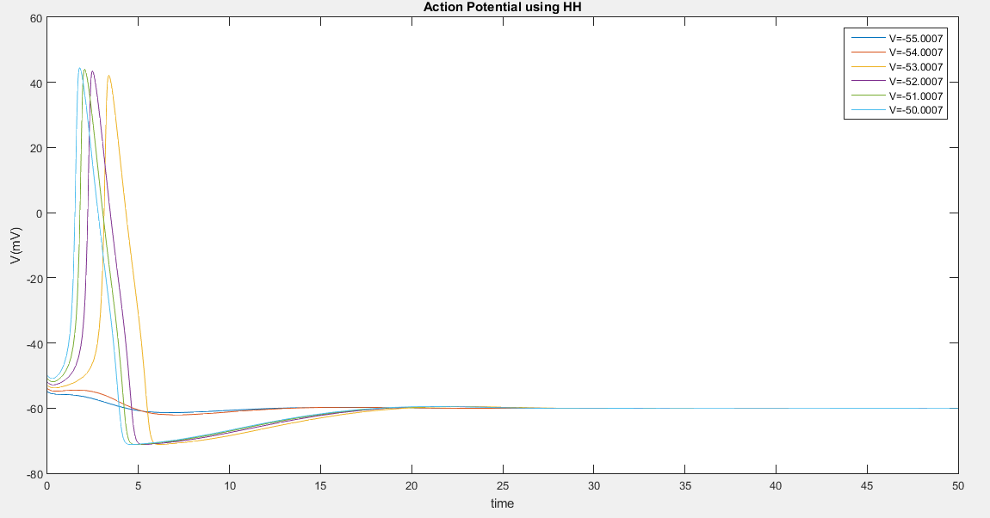

As we can see, this reduced model has the same general behavior as the overall HH model. However, since we have set m to minf, the spike onset time reduces and the spike height increases.

1. Phase plots of n-V reduced HH system including case of myotonia

As f increases, at first we have only one stable equilibrium point. But then, as V-null cline shifts up, we have a bifurcation and a saddle node and unstable spiral are introduced. As f increases further, there is a **Hopf bifurcation and the unstable spiral becomes a stable spiral.** This leads to a second attracting state in the system and is the main cause of muscle myotonia; the neuron is depolarized and brought to a stable state, thus preventing further depolarization, unless an external current impulse is provided.

1. Anode break excitation is observed as follows. Iext =0 for t = 0 to 20ms. Then Iext = -3 µA/cm2 for t = 20 to 40ms and finally Iext is brought back to ‘0’ for t= 40 to 100ms.

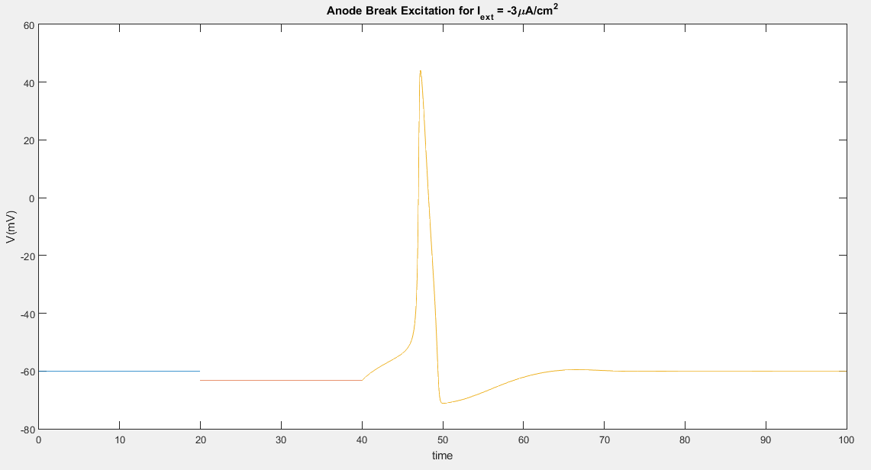

We see a sudden spiking when clamp voltage is released. The reason for this weird event is the dynamics of m and h. On decreasing V, m=minf reduces and h=hinf increases. However, when the clamp is released, minf, having a small time constant, quickly returns to its original higher value, while hinf, having larger time constant, takes time to decrease. Thus, there is an overall increase (stochastically) in Na+ ion channel gating, and this disturbance results in an action potential.

1. Phase plots for cases 1&2

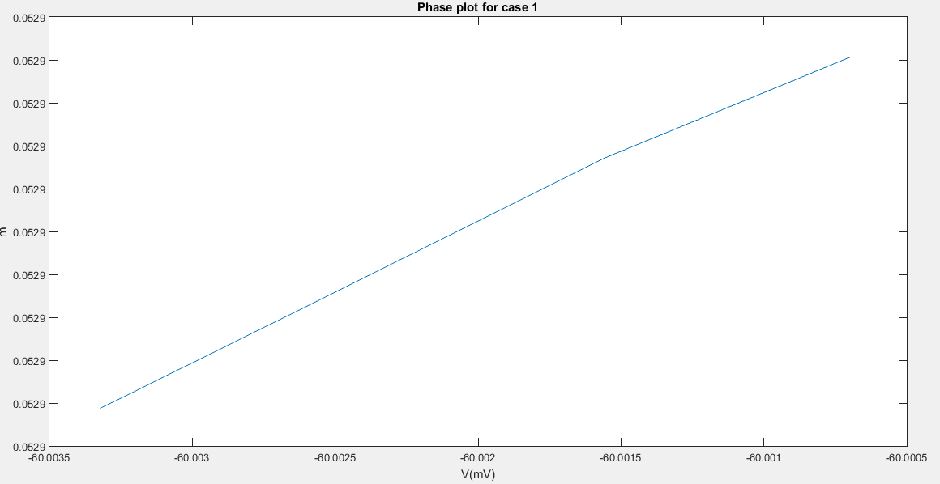

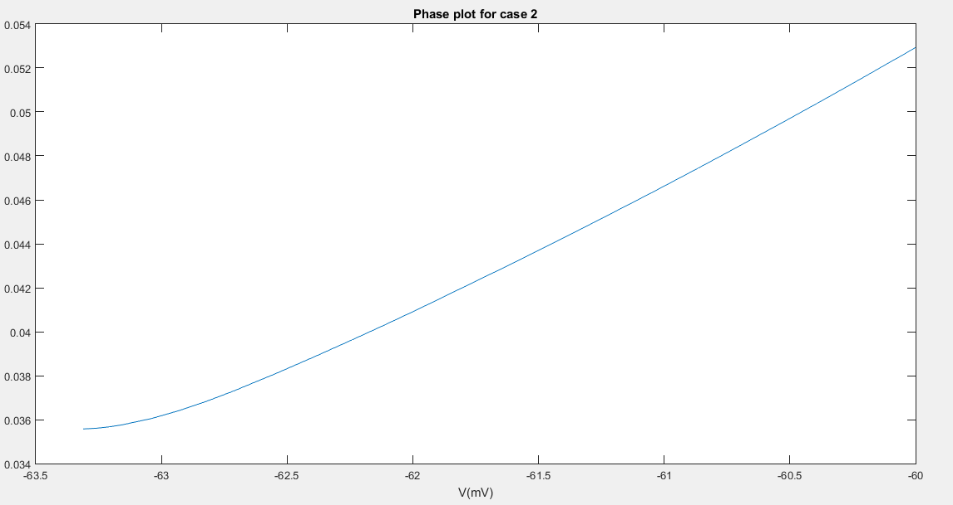

At the values at end of anodal stimulus, we have a change in values of ninf and hinf from that at rest and as a result, the V-nullcline shape changes a bit, so that there is only one equilibrium now, instead of 3. This equilibrium point is stable and when started from (Vr, weq), which was an earlier equilibrium point, the trajectory goes to the third and only remaining equilibrium point, resulting in an action potential.

**Note that since this is an m-V reduced system, we aren’t actively modelling the dynamics of** **depolarization. Hence, the model predicts (rightly), that the potential will go to peak and saturate.**

The main takeaway is that there will be an action potential, due to the exploitation of the dynamics of m and h.